General Lexicon

What is General Lexicon
# Source: AI Source: Provided by: [Data Path: Persons Table -> ID Column: 1, Name_En Column: Motasem Essam] -> From: [Chatgpt (GPT-4-turbo)] on [7/29/2025]
A General Lexicon is a broad, inclusive collection of everyday vocabulary used across multiple contexts and domains. It reflects the common core of a language that speakers use in daily communication, as opposed to specialized or technical terms found in domain-specific lexicons.

🔹 Key Features of a General Lexicon
# Source: AI Source: Provided by: [Data Path: Persons Table -> ID Column: 1, Name_En Column: Motasem Essam] -> From: [Chatgpt (GPT-4-turbo)] on [7/29/2025]
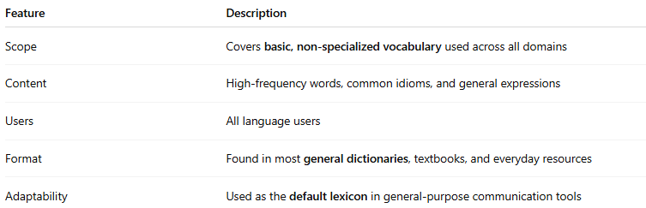
Feature | Description
Scope | Covers basic, non-specialized vocabulary used across all domains
Content | High-frequency words, common idioms, and general expressions
Users | All language users
Format | Found in most general dictionaries, textbooks, and everyday resources
Adaptability | Used as the default lexicon in general-purpose communication tools

🔹 What It Includes
# Source: AI Source: Provided by: [Data Path: Persons Table -> ID Column: 1, Name_En Column: Motasem Essam] -> From: [Chatgpt (GPT-4-turbo)] on [7/29/2025]
- Basic nouns: house, cat, teacher
- Common verbs: go, make, take
- Adjectives/adverbs: happy, fast, very
- Phrasal verbs: wake up, look for
- Simple idioms and collocations: break the ice, heavy rain

🔹 Examples of Use
# Source: AI Source: Provided by: [Data Path: Persons Table -> ID Column: 1, Name_En Column: Motasem Essam] -> From: [Chatgpt (GPT-4-turbo)] on [7/29/2025]
- Conversational speech:
“She went to the store to buy some food.”
- Media and journalism:
“The weather is expected to be sunny this weekend.”
- Primary education and language acquisition
(e.g., Dolch Sight Words, CEFR A1–B1 vocabulary lists)

🔹 General vs. Domain-Specific Lexicon
# Source: AI Source: Provided by: [Data Path: Persons Table -> ID Column: 1, Name_En Column: Motasem Essam] -> From: [Chatgpt (GPT-4-turbo)] on [7/29/2025]
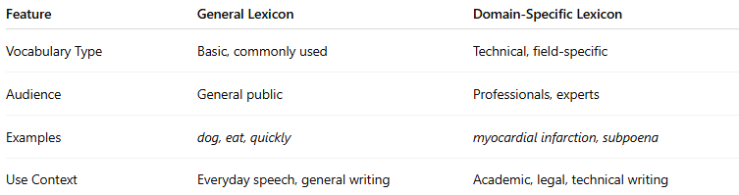
Feature | General Lexicon | Domain-Specific Lexicon
Vocabulary Type | Basic, commonly used | Technical, field-specific
Audience | General public | Professionals, experts
Examples | dog, eat, quickly | myocardial infarction, subpoena
Use Context | Everyday speech, general writing | Academic, legal, technical writing

🔹 General Lexicons Are Found In:
# Source: AI Source: Provided by: [Data Path: Persons Table -> ID Column: 1, Name_En Column: Motasem Essam] -> From: [Chatgpt (GPT-4-turbo)] on [7/29/2025]
- Standard dictionaries (Oxford, Merriam-Webster)
- Corpora like the British National Corpus (BNC) or COCA
- Language-learning platforms
- Baseline NLP models (before domain tuning)

